Subject-verb agreement with Genitive of Quantification in Polish *co* and *który* object relative clauses

Paulina Łęska (Adam Mickiewicz University in Poznań)

This paper examines subject-verb agreement in Polish object relative clauses (RCs) of two types, namely co and który-relatives, in which the modified head noun (HN) is a Genitive of Quantification phrase (GoQ). When it functions as a subject, this phrase forces default agreement on the verbal predicate. However, whenever it occupies the subject of a RC position, the agreement may vary between default and full agreement, depending on the type of the RC and the grammatical gender of the HN. This study compares subject-verb agreement with GoQ in subject relatives (examined in Łęska 2016) with the patterns found in object RCs, based on the results of a survey of acceptability judgements for co and który object RCs. The results revealed an asymmetry between subject and object RCs in the possibility of default agreement, indicating that the Case attraction analysis of Polish RCs should be further restricted to apply only to the former.

1. Polish *co* and *który*-relatives

1.1. Introduction

This section is a brief overview of previous research on Polish RCs regarding their distribution, case mismatches between the head noun and the relative operator, and asymmetries in the derivation of *co* and *który*-RCs.

1.2. The distribution of *co* and *który* relative markers

The two types of RCs under investigation are introduced by different relative markers, namely the relative pronoun *który* and the complementizer *co*. The former is a D-linked relative pronoun which requires a nominal restriction and is used to relativize full nominal heads in so-called ‘headed relatives’ (Citko 2004). According to Citko, headed relatives can be introduced only by the relative pronoun *który*, which can relativize both animate and inanimate heads. The agreement between the pronoun and the relative clause head is in gender and number (but not case), as in (1):

(1) a. Mężczyzna, **którego** spotkałem wczoraj, jest lekarzem.

man.3sg.m.nom który.3sg.m.acc I.met yesterday is doctor

‘A man who I met yesterday is a doctor.’

b. Znalazłam książki, **które** wczoraj zgubiłeś.

I.found books.3pl.f.acc który.3pl.f.acc yesterday you.lost

‘I found the books which you lost yesterday.’

However, Polish headed relatives can also be introduced by the uninflected relative marker *co*. Although this relativization strategy is limited to spoken language, relatives with the uninflected *co* are considered fully grammatical (Buttler et al. 1971). Generally, in non-standard Polish, the marker *co* can occur in the same context as the relative pronoun *który* (example (2)), except for non-restrictive RCs, for which only *który* can be used, as can be seen in (3), illustrating an appositive RC (Borsley 1981; 1984).

(2) a. Mężczyzna, **co** spotkałem go wczoraj, jest lekarzem.

man.3sg.m.nom comp I.met him yesterday is doctor

‘A man who I met yesterday is a doctor.’

b. Znalazłam książki, **co** wczoraj je zgubiłeś.

I.found books.3pl.f.acc compyesterday them you.lost

‘I found the books which you lost yesterday.’

(3) Adam, \***co/którego** znam od lat, mieszka teraz w Anglii.

Adam comp/who.acc I.know from years lives now in England

‘Adam, whom I have known for years, lives in England right now.’

When it comes to agreement, *co* in headed relatives does not agree in phi-features or case with the head noun. This observation has been used to argue that *co* in this type of RC has complementizer status. Compare the light headed relative in (4a) to the headed relative in (4b) (Citko 2004).

(4) a. To jest coś, **czego**/\***co** tutaj wczoraj nie było.

this is somethingNOM whatGEN/*COMP here yesterday not was

‘This is something that was not here yesterday.’

b. To jest ta książka, **co** jej/**\*czego** tutaj wczoraj nie było. this is this book comp her/*whatGEN here yesterday not was

‘This is the book that was not here yesterday.’

As opposed to light headed relatives, in which *co* inflects for case and is therefore considered to be a relative pronoun, headed relatives, in which *co* remains uninflected and a resumptive pronoun is used to mark the relativization site, are considered to be introduced by a complementizer. Thus, despite the fact that the form of the uninflected relative marker *co* is homophonous with the nominative/accusative form of the relative pronoun *co*, there is some evidence in support of the complementizer status of *co* in headed RCs. According to Bondaruk (1995), the relative marker *co* can be used in the same context as the complementizer *żeby* in purpose clauses, as in (5a). As can be seen in (5b), *co* followed by the particle *by* can replace the complementizer *żeby*, although sentences like this are mainly restricted to dialectal use (Bondaruk 1995: 35).

(5) a. Kupił pióro, **żeby** nim pisać.

he.bought pen in.order.to with.itINSTR write

b. Kupił pióro, **co by** nim pisać.

he.bought pen comp in.order.to with.itINSTR write

‘He bought a pen to write with.’

Homophony between *wh*-pronouns and complementizers is common cross-linguistically, since the former are often a source for the development of the latter (Citko 2004: 108). According to Minlos (2012), the main diachronic source of this invariable lexeme in Slavic relative constructions was an inflected pronoun functioning as either an interrogative, an indefinite, or a relative pronoun. This lexeme stems from Common Slavic \**čьto* (Russian *что*, BCS – Bosnian / Croatian / Serbian *što*) or \**čьso* (Czech, Polish *co*, Slovak *čo*). Table 1 below shows the inflectional paradigms of the Polish relative pronouns *co* and *który*. As for other language families, a detailed account of the asymmetries between relative operators and complementizers is offered in Bacskai-Atkari (2016) for Uralic (Hungarian) and Germanic languages. Diachronic evidence presented in Bacskai-Atkari (2016) indicates that the Hungarian declarative complementizer *hogy* ‘COMP’ developed via the relative cycle from an operator, which could function as either an interrogative or relative operator as well as a complementizer, into a lower C0 head which was then reinterpreted as a higher C0 head.

Table 1: Case inflection on the relative markers ***który*** and ***co***. Plural gender distinction: virile (masculine personal), non-virile (masc. non-personal, feminine, neuter).

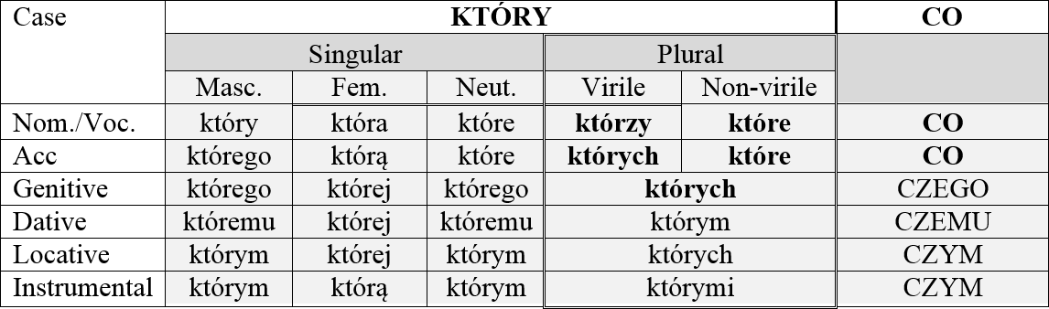

1.3. Case mismatches and resumption

Polish *który*-relatives show a mismatch between the cases assigned to the external and the internal head, regardless of the position occupied by the two heads, as can be seen in (6). The head noun *tę kobietę* ‘this woman’ is assigned accusative case in the matrix clause, being a direct object of the verb *spotkałem* ‘I-met’, whereas the relative pronoun in the embedded clause bears nominative case, occupying the subject position of the relative clause. Example (6b) shows the opposite situation, in which the external head is a nominative subject and the internal head is an object bearing accusative case. This observation has been used to argue against the raising analysis of *który*-relatives (Borsley 1997), since one chain can be assigned only one Case (Chomsky 1982).[1]

(6) a. Spotkałem tą kobietę, **która** przyszła do ciebie wczoraj. I.met thisACC womanACC whoNOM came to you yesterday

‘I met the woman who came to you yesterday.’

b. Ta kobieta, **którą** Jan lubi, przyszła do mnie wczoraj.

thisNOM womanNOM whoACC Jan likes came to me yesterday

‘The woman who John likes came to me yesterday.’

c. Kobieta, **o której** mówisz, przyszła do mnie wczoraj.

womanNOM about whoLOC you.speak came to me yesterday

‘The woman you speak about came to me yesterday.’

As opposed to *który*-relatives, in which the relativization site is always realized as a gap, *co*-relatives can either use the bare strategy or the resumption strategy. Since the complementizer *co* is not marked for case by the predicate of the relative clause, the relativization site is occupied by a resumptive pronoun which reflects this case marking. Such relative clauses are analysed as being derived via External Merge of the resumptive pronoun, which is bound by a null operator merged in SpecCP (Borer 1984; Chomsky 1977; Lavine 2003; McCloskey 1990; 2002; Merchant 2004; Safir 1986; Shlonsky 1992). This analysis, however, does not account for the bare strategy in which no resumptive pronoun is used. Generally, the resumptive pronoun is obligatory whenever the head noun is the direct or indirect object, whereas it is impossible with subject head nouns, as in (7):

(7) a. mężczyzna, **co** **(*on)** biegnie

manNOM that heNOM runs

‘the man that is running’

b. mężczyzna, **co *(go)** Jan widzi

manNOM that himACC Jan sees

‘the man that John sees’

c. mężczyzna, **co *(mu)** Jan pokazuje książkę

manNOM that himDAT Jan shows book

‘the man that John is showing him the book’

However, research on resumption strategies in Slavic *čto*-relatives shows that it is possible to drop the resumptive pronoun in a broader set of contexts. This observation has been made for Croatian *što*-relatives in Gračanin-Yuksek (2013: 29) and can also be extended to Polish examples. As can be seen in (8a) and (9a), the obligatory resumptive pronouns *ga* and *go* ‘him’ are marked for accusative case within the relative clause, whereas the subject is marked for nominative, assigned by T0 of the main clause. In these cases, the resumptive pronouns are obligatory. In (8b) and (9b), on the other hand, both the resumptive pronoun and the relativized object are marked for accusative by the predicates of the embedded and the main clause, respectively. As a result, the pronoun can be absent, which is confirmed by the grammaticality of these two examples (all Croatian examples used in this and the following sections are from Gračanin-Yuksek 2013).

(8) Croatian

a. Čovjek [ **što** sam **\*(ga)** video] voli Ivu.

manNOM that aux himACC seen loves Iva

‘The man that I saw loves Iva.’

b. Upoznao sam čovjeka [ **što (ga)** Iva obožava].

met aux manACC that himACC Iva adores

‘I met the man that Iva adores.’

(9) Polish

a. Mężczyzna, [**co *(go)** widziałem], kocha Marię.

manNOM that himACC saw loves Mary

‘The man that I saw loves Mary.’

b. Widziałem mężczyznę, [ **co (go)** Maria kocha].

I.saw manACC that himACC Mary loves

‘I saw the man that Mary loves.

The resumptive pronoun marked for accusative case is also optional when the relativized subject has a syncretic nom/acc form, as can be seen in Croatian (10) and Polish (11):

(10) Dijete [**što** sam **(ga)** vidio] voli Ivu.

childNOM that aux himACC saw loves Iva

‘The child that I saw loves Iva.’

(11) Dziecko, [**co (je)** widzałem wczoraj], kocha Marię.

childNOM that himACC I.saw yesterday loves Mary

‘The child that I saw yesterday loves Mary.’

The examples in (10) and (11), as opposed to the examples in (8a) and (9a), involve a neuter subject *dijete/dziecko* ‘child’, the form of which is ambiguous between nominative and accusative. The fact that if this noun was assigned case by the predicate of the relative clause, it would appear in the same form, makes it possible to realize the relativization site as a gap. Therefore, it could be posited that it is the morphological form of the head noun, and not the formal identity of case assigned by the main and the embedded predicate, which makes the resumptive pronoun optional. This correlation was formalized as Morphological Case Matching in Gračanin-Yuksek (2013: 30), the definition of which is given in (12) below:

(12) **Morphological Case Matching**

In a *što*-RC, an RP may be omitted if the head of the RC bears the same morphological case that it would bear if it were case marked by the element that case-marks the RP.

Therefore, case marking on both the external and internal head may be the key issue in the analysis of resumption strategies in *co*-relatives. The next section compares the structures of these two types of RCs and their derivation.

1.4. The structure and derivation of *co*- and *który*-RCs

The two types of RCs discussed here, being introduced by two different relative markers, have usually been analysed as having different structures. The asymmetry between these two types of relatives in Polish and Russian was extensively discussed in Szczegielniak (2005; 2006). In his analysis, he proposes that the head noun in *co* relative clauses not only can but must reconstruct to a position inside the relative clause, whereas the head noun in *który* relative clauses cannot. Some support for reconstruction in Polish, as well as Russian, *co*-relatives comes from examples of idiom splitting. Because only this type of relative allows for reconstruction of the head noun, it can split up idiom chunks, except when the resumption strategy is used; compare (13a-c) from Szczegielniak (2006: 377). A similar observation has been made for Serbian relatives (Mitrović 2012).

(13) a. ?? słów, **których** on nie rzucał na wiatr

words whichGEN he not throw on wind

b. słów, **co** on nie rzucał na wiatr

words that heNOM not throw on wind

c. ?? słów, **co** on **je** nie rzucał na wiatr

words that heNOM themACC not throw on wind

‘empty promises that he did not make’

Yet, another asymmetry between *co*- and *który*-relatives can be observed in appositive relative clauses, which are analysed as being separate from the head noun (Chierchia & McConnell-Ginet 1999). The fact that *co*-relatives do not allow an appositive reading suggests the presence of head noun reconstruction. Again, when the resumption strategy is used, *co*-relatives pattern with *który-*relatives, as demonstrated in (14) from Szczegielniak (2006: 378):

(14) a. *Maria, **co** Marek pocałował, poszła do domu.

MaryNOM that Mark kissedwent to home

b. Maria, **którą** Marek pocałował, poszła do domu.

MaryNOM whoACC Mark kissed went to home

c. Maria, **co ją** Marek pocałował, poszła do domu.

MaryNOM that herACC Mark kissed went to home

‘Mary, who Mark kissed, went home.’

The above-mentioned arguments point to obligatory reconstruction in *co*-relatives with no resumptive pronouns, suggesting the movement of the head noun out of the relative (Åfarli 1994; Bhatt 2002; Bianchi 1999; Brame 1968; De Vries 2002; Hornstein 2000; Kayne 1994; Safir 1999; Schachter 1973; Vergnaud 1974; Zwart 2000). However, some evidence from binding effects points to the contrary. As was noticed in Gračanin-Yuksek (2013) for Croatian *što*-relatives, and as can also be observed in Polish *co*-relatives, a possessive anaphor contained in the head noun cannot be bound by the subject of the relative clause, as shown in (15). The absence of reconstruction can also be seen in (16), where the possessive pronoun in the head noun can corefer with an element in the relative clause, but not with one in the matrix clause (Croatian examples from Gračanin-Yuksek 2013).

(15) a. Croatian

Jani voli svakog svogi/*j psa **što** (ga) je Ivaj dovela ___ na izložbu.

Jan loves every self’s dogACC that himACC aux Iva brought on exhibition

b. Polish

Jani kocha każdego swojegoi/*j psa **co** (go) Iwonaj Jan loves every self’s dogACC that himACC Iwona zabrała ___ na wystawę.

brought on exhibition

‘Jani loves every one of hisi/*j dogs that Iva/Iwonaj brought to the exhibition.’

(16) a. Croatian

Jani voli svakog njegovogj/k/*i psa **što** (ga) je Vidj

Jan loves every his dogACC that himACC aux Vid

doveo ___ na izložbu.

brought on exhibition b. Polish

Jani kocha każdego jegoj/k/*i psa, **co** (go) Adamj

Jan loves every his dogACC that himACC Adam

zabrał ___ na wystawę.

brought on exhibition

‘Jani loves every one of hisj/k/*i dogs that Vid/Adamj brought to the exhibition.’

The lack of reconstruction of the head noun inside the relative, therefore, points to the matching analysis of *co*-relatives, which assumes that they contain both an external head to which the relative is adjoined and an internal one merged in the position of relativization (Bhatt 2002; Sauerland 2002; Hulsey & Sauerland 2006). After the movement of the internal head to SpecCP of the relative clause, it undergoes deletion under identity with the external head (by a process called *relative deletion*; Sauerland 2002). In order to further examine the structure of Polish *co-* and *który*-RCs, I will investigate subject-verb agreement patterns in RCs with Genitive of Quantification head nouns. GoQ phrases, when in subject position, induce obligatory default agreement on the matrix clause predicate. The aim of my study is to check whether default agreement on the verbal predicate inside the RC can also be triggered by a GoQ head noun, which would reveal the properties of agreement between the external head and the predicate inside the RC.

2. Genitive of Quantification as a head noun

2.1. Introduction

This section aims at describing the possible patterns of subject-verb agreement with Genitive of Quantification as a relativized head noun in object and subject positions, and examining how they can account for the structure of Polish *co-* and *który*-relative clauses. Based on agreement patterns, it will be shown that there is an agreement relation established between the external head noun and the relative operator that allows for Case from the HN to be optionally transmitted to the relative. This mechanism, however, applies only when the two match in morphological case and are probed by the T0 of the matrix clause and the RC respectively. The availability of different agreement patterns inside *co-* and *który*-RCs also suggests that they cannot be derived via raising of the internal head, which would yield only default agreement on the RC predicate, contrary to fact.

2.2. The Genitive of Quantification phenomenon

The Genitive of Quantification phenomenon has been described to a large extent for Slavic languages in Bošković (2006), Franks (1994; 2002), Przepiórkowski (2004), Rutkowski (2002), and Willim (2003), to name but a few. In Polish, genitive case marking is forced on a noun which is modified by a higher numeral or a lower virile numeral, as well as by certain quantifiers such as *wiele* ‘many’, *kilka* ‘a few’, *pare* ‘a couple of’, etc. Such numeral phrases do not induce subject-verb agreement in main clauses, as can be seen in (17), in which the verb obligatorily appears in the 3sg neuter form, regardless of the grammatical gender of the noun.

(17) a. Siedmiu mężczyzn weszło/*weszli do domu.

seven-ACC men-GEN,VIR. entered-3SG,NEUT./3PL,VIR into house

*‘Seven men entered the house.’*

b. Siedem kobiet weszło/*weszły do domu.

seven-ACC women-GEN,NON-VIR entered-3SG,NEUT./*3PL,NON-VIR into house

‘Seven women entered the house.’

The analysis of Polish GoQ structures proposed in Witkoś & Dziubała-Szrejbrowska (2016) follows the idea that probing for phi-features is possible for T only when nominative case is being checked (Bošković 2006). Additionally, they assume that high numerals in Polish are either accusative or caseless, which prevents T0 from probing for phi-features whenever they modify subject nominals. As a result, T defaults to 3sg neuter. This assumption is necessary to account for default agreement with GoQ subjects in Polish, which, unlike with Russian GoQ, is obligatory in all contexts. Nevertheless, these agreement patterns are different when the GoQ phrase is a relativized head noun, a situation which is described in the following two sections. It will be shown that default agreement on the predicate inside the RC can be induced by GoQ head nouns only when these are subjects of main clauses and are relativized by *co*- and (non-virile) *który*-RCs.

2.3. Agreement with object GoQ head nouns of *co* and *który* RCs

The aim of this and the following section is to investigate the asymmetry between object and subject *co*- and *który*-RCs in Polish with respect to agreement between a GoQ head noun and the verbal predicate within the RC, starting with object relatives. In order to examine the possible subject-verb agreement patterns within Polish *co* and *który* relative clauses in which the head noun is an object of the main clause, a survey was conducted measuring acceptability judgements by Polish native speakers. The survey employed a 7-point Likert scale ranging from 1 (totally unacceptable) to 7 (totally acceptable) and was completed by 110 students (103 women, 7 men, Mage = 21.68, SD = 1.94), of whom 107 were students or graduate students of higher education institutions in Poland (including universities in Warsaw, Poznań, Tricity, Łódź, and Lublin). The questionnaire consisted of 132 sentences, 60 of which were filler sentences. It involved RCs modifying Genitive of Quantification direct and indirect objects. In particular, the relativized subject head noun was used as the direct object marked for accusative case (18a) and the indirect object marked for oblique case, realized either by a preposition (18b) or simply a case suffix (18c). The same conditions were used for both *co-*relatives with either virile (masculine personal) or non-virile (feminine, neuter, masculine impersonal) nouns and *który*-relatives with non-virile nouns.[2] All these types were further divided into default agreement (3sg, neuter) and full agreement (in person, number, and gender) options.

(18) a. Poznałem siedem kobiet, **które**

I.met seven-ACC women-GEN,NON-VIR who-NOM/ACC

weszły/??weszło do domu.

entered-3PL,NON-VIR/3SG,NEUT into house

‘I met seven women who entered the house.’

b. Rozmawiałem z siedmioma kobietami, **które**

I.talked with seven-INST women-INST,NON-VIR who-NOM/ACC

weszły/??weszło do domu.

entered-3PL,NON-VIR/3SG,NEUT into house

‘I talked to seven women who entered the house.’

c. Przyglądałem się siedmiu kobietom, **które**

I.watched REFL seven-DAT women-DAT,non-vir who-NOM/ACC weszły/??weszło do domu.

entered-3PL,NON-VIR/3SG,NEUT into house

‘I was looking at seven women who entered the house.’

As can be observed, the GoQ phrase in (18a) displays a heterogeneous pattern in which the quantifier is accusative whereas the noun complement is genitive. The examples in (18b-c), on the other hand, show a homogeneous pattern of GoQ in which both the quantifier and the noun complement appear in an oblique case form. The reason for using these two patterns is to test whether case-marking on the quantifier (accusative vs. oblique) has any bearing on subject-verb agreement with the RC predicate.

Let us first consider the results for *który*-relatives, presented in **Figure 1** below. As can be observed, neither of the relativized object head nouns can induce default agreement on the verbal predicate of the RC. There is a significant difference in acceptability judgements between full agreement and default agreement options. The results are as follows: accusative GoQ (default agr: M = 2.56, SE = .13; full agr: M = 6.52, SE = .06), GoQ marked for oblique case realized as a preposition (default agr: M = 2.34, SE = .17; full agr: M = 5.95, SE = .24), GoQ marked for oblique case without preposition (default agr: M = 2.36, SE = .09; full agr: M = 5.57, SE = .38).

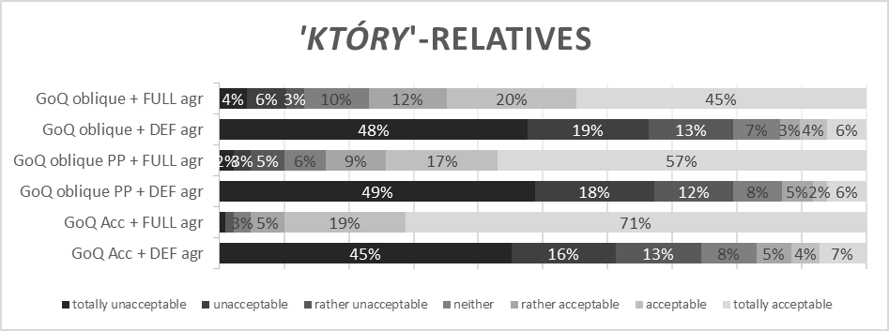

Figure 1: Acceptability judgements for ***który***-relatives with non-virile head nouns modified by GoQ in main clause object position (accusative GoQ, oblique prepositional phrase (PP) GoQ, and oblique GoQ without preposition : default vs. full agreement).

When it comes to *co*-relatives, it also appears that optionality in agreement is impossible when the head noun occupies the main clause object position. The results for all responses are as follows: accusative GoQ object (default agr: M = 1.98, SE = .13; full agr: M = 2.55, SE = .11), GoQ marked for oblique case realized as a preposition (default agr: M = 1.84, SE = .08; full agr: M = 2.59, SE = .16), GoQ marked for oblique case without preposition (default agr: M = 1.81, SE = .06; full agr: M = 2.43, SE = .11).[3]

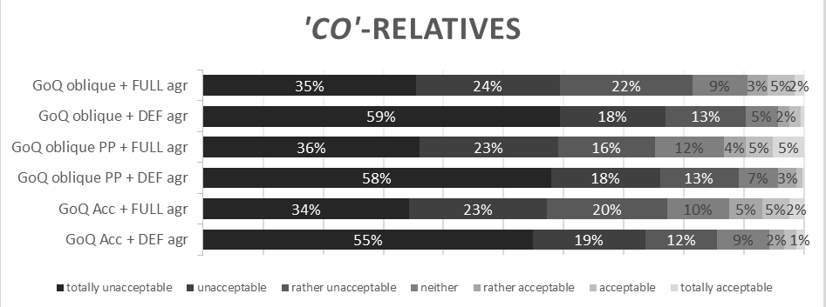

Figure 2: Acceptability judgements for *co*-relatives with virile and non-virile head nouns modified by GoQ in main clause object position (Accusative GoQ, oblique prepositional phrase (PP) GoQ, and oblique GoQ without preposition : default vs. full agreement).

Due to the speaker variation regarding the acceptability of *co*-relatives, it seems necessary to look separately at the individual responses of the participants who accept *co*-relatives in general. Therefore, these responses were selected, of which the mean rating for *co*-relatives was more than 4 (n = 10, which constitutes only 9% of all the responses). The results presented in **Figure 3** below clearly show that there is a significant difference in acceptability between default and full agreement in *co*-relatives with both virile and non-virile head nouns.

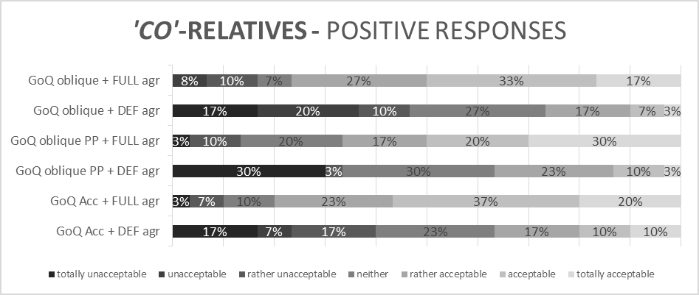

Figure 3: Acceptability judgements of participants who accept *co*-relatives in general: full vs. default agreement.

Additionally, a two way ANOVA test was applied, which showed a significant main effect of relative clause type (6 types: 3 types of *co*-relatives and 3 types of *który*-relatives) (*F*(5,72) = 90.442 , *p* = .000) and a significant main effect of agreement (full vs. default) (*F*(1,72) = 484.176, *p* = .000).

Altogether, these results clearly demonstrate that default agreement with the GoQ in object relatives, either *który*-(19a) or *co*-relatives (19b), is banned.

(19) a. Poznałem siedem kobiet, **które**

I.met seven-ACC women-GEN,NON-VIR who-NOM/ACC weszły/??weszło do domu.

entered-3PL,NON-VIR/3SG,NEUT into house

b. Poznałem siedem kobiet, **co**

I.met seven-ACC women-GEN,NON-VIR comp weszły/??weszło do domu.

entered-3PL,NON-VIR/3SG,NEUT into house

‘I met seven women who entered the house.’

Despite the statistical difference in acceptability between *który*- and *co*-relatives, the main effect of agreement indicates that both these types of RCs show a strong preference for full agreement on the verb. Let us now turn to subject RCs, in which these patterns are quite different and more complex.

2.4. Agreement with subject GoQ head nouns of *co*- and *który*-RCs.

The study reported in Łęska (2016) shows that when a numeral (GoQ) subject head noun is relativized, the relativization site also being the subject position, agreement with the verbal predicate inside the RC can be either default or full agreement.[4] These two agreement options, however, depend on the grammatical gender of the head noun in combination with the RC type. In that study, *co-* and *który*-relatives were examined, the former with virile and non-virile, and the latter with non-virile GoQ head nouns. For each condition, two agreement options were compared, namely default vs. full agreement. As regards *który*-relatives, default agreement with the verbal predicate within the relative is possible only with non-virile subjects, in which case full agreement is still preferred. Virile subjects, on the other hand, allow only full agreement, as can be seen in (20).

(20) a. Siedmiu mężczyzn, **którzy** weszli/*weszło

seven-ACC men-GEN,VIR who-NOM entered-3PL,VIR/*3SG,NEUT. do domu, okradło nas.

into house robbed3SG,NEUT us

‘Seven men who entered the house robbed us.’

b. Siedem kobiet, **które**

seven-ACC women-GEN,NON-VIR who-NOM/ACC

weszły/%weszło do domu, okradło nas.

entered-3PL,NON-VIR/3SG,NEUT. into house robbed3SG,NEUT us

‘Seven women who entered the house robbed us.’

When it comes to *co*-relatives, the asymmetry between virile and non-virile head nouns disappears. Thus, default and full agreement are equally possible regardless of the grammatical gender of the head noun, with a preference for full agreement, as shown in (21).

(21) a. Siedmiu mężczyzn, **co** weszli/%weszło do

seven-ACC men-GEN comp entered-3PL,VIR/3SG,NEUT. into domu, okradło nas.

house robbed3SG,NEUT us

b. Siedem kobiet, **co** weszły/%weszło

seven-ACC women-GEN comp entered-3PL,NON-VIR/3SG,NEUT.

do domu, okradło nas.

into house robbed3SG,NEUT us

The asymmetry between the two types of RCs is attributed to the differing properties of the relative markers *co* and *który*. In contrast to the relative pronoun *który*, the invariable relative marker *co* does not share number and gender features with the subject nominal and it does not inflect for case. In this configuration, which involves subject relativization, no resumptive pronoun is present in a *co*-relative, and the relativization site is realized as a gap. Since the relative operator is null, no agreement in phi-features with the head noun can be observed. In *który*-relatives, on the other hand, the relative pronoun must agree in phi-features with the head noun, which indicates that feature sharing between the two has taken place. Crucially, the two relative pronouns *którzy*NOM-VIR in (17a) and *które*NOM/ACC-NON-VIR in (17b) differ not only in gender, but also in case marking. To observe case agreement between the relative pronoun and the GoQ phrase, it is possible to use it as an interrogative pronoun in *wh*-questions. As can be seen in (22), the pronoun agrees in phi-features, number, and case with the subject noun. Example (23) shows that the case form of the pronoun must be compatible with the case form of the higher numeral.

(22) a. **Którzy** mężczyżni przyszli wczoraj?

whichNOM menNOM came3PL,VIR yesterday

b. **Które** kobiety przyszły wczoraj?

whichNOM/ACC womenNOM came3PL, NON-VIR yesterday

(23) a. **Których/*którzy** pięciu mężczyzn przyszło wczoraj?

whichACC/GEN//*NOM fiveACC menGEN came3SG,NEUT. yesterday

b. **Których/które** pięć kobiet przyszło wczoraj?

whichGEN//NOM/ACC fiveACC womenGEN came3SG,NEUT. yesterday

Since the nominal is modified by the numeral, the nominative form of a **virile** *wh*-pronoun is incompatible with the numeral phrase and, instead, the accusative/genitive form is used, as in (23a). In the case of a **non-virile** *wh*-pronoun, both nominative/accusative and genitive forms are grammatical, as in (23b). This indicates that the case marking on the *wh*-pronoun is accusative rather than nominative for both virile and non-virile pronouns when they modify accusative-marked higher numerals. This difference is crucial for the analysis of subject-verb agreement patterns inside *który*-relatives, where subject-verb agreement options depend on the gender feature of the head noun, namely virile vs. non-virile. Note that this feature alone does not influence verbal agreement in main clauses, in which both virile and non-virile quantified subjects force default agreement – see (17) above. Therefore, the reason for the differences in agreement patterns in RCs cannot be the gender of the head noun itself, but must rather be the fact that the non-virile head noun will appear with the non-virile *wh*-pronoun *które*, which has a syncretic nominative/accusative form, unlike the virile *wh*-pronoun *którzy*, which is nominative. This correlation between case syncretism of *wh*-pronouns and subject-verb agreement in RCs will be captured in terms of a Case attraction analysis in the next section.

2.5. The Case attraction analysis

* + 1. Introduction

As proposed in Łęska (2016), a possible explanation for the subject-verb agreement patterns discussed above could come from the phenomenon of Case attraction, whereby the relative operator appears with the case morphology of the external head, as opposed to the case governed by the internal case probe of the RC. Case attraction is attested in a number of languages, such as Persian (Aghei 2006), Latin (Bianchi 1999), Ancient Greek (Bianchi 1999), Old and Middle High German (Pittner 1995), and German (Bader & Bayer 2006). According to Bader & Bayer (2006), the head NP and the relative operator share number and person features, but the feature sharing is erroneously extended to Case features, resulting in case attraction effects. This mechanism is generally optional and is only possible when the matrix case probe is more oblique than the case probe of the relative, in line with the following Case hierarchy from Pittner (1995: 200–202); see also Grosu (1994: 122): GEN > DAT > ACC > NOM (Georgi & Salzmann 2014: 349). Another account of Case attraction is provided in Bianchi (1999) along the lines of the raising analysis of RCs. According to Bianchi (1999), after movement to SpecCP, the relative HN together with its modifiers is governed by the external D0, which provides it with Case. Thus, assuming that the checked Case can be optionally erased, as proposed in Chomsky (1995: 279–282), the HN can receive another Case under government (Bianchi 1999: 95). Therefore, Case attraction, as in Latin (24) or Ancient Greek (25) (examples cited in Bianchi 1999: 94–95), can be taken as evidence for this hypothesis.

(24) Latin

notante iudice quo nosti ACC 🡪 ABL

judgingABL the judgeABL whoABL (you) know

‘judging the judge whom you know’

(25) Ancient Greek

άνδρες άξιοι  της έλευθερίας ής κέκτησθε men worthy theGEN freedomGEN whichGEN you.possess

‘men worthy of the freedom that you enjoy’ ACC 🡪 GEN

In what follows, I will account for the asymmetries between *co* and *który* relatives, as well as between the subject and object relatives described in the previous sections. To this end, I will implement a Case attraction mechanism making use of some additional assumptions.

2.5.2. Case attraction in subject relative clauses

As suggested in Łęska (2016), the derivation of Polish *który*-subject relatives along the lines of the Case attraction analysis could proceed in the following steps. 1) In both virile (26) and non-virile (27), the relative pronoun undergoes Agree with the T probe, checking structural Nominative Case, and then moves to SpecCP. 2) Next, the external head QP is Merged, bearing Accusative Case, which blocks the Agree relation with the *matrix* T probe, resulting in default agreement on the *matrix* verbal predicate. Assuming that default agreement is a result of exceptional non-Nominative marking on the subject QP, the same non-Nominative marking on the relative operator should be the source for default agreement within the RC. 3) Thus, when the head QP enters into an agreement relation (or feature sharing; Bader & Bayer 2006) with the relative pronoun in order to check phi-features, the Accusative Case feature of the HN, or, more specifically, of the higher numeral, is optionally transmitted onto the non-virile relative pronoun, as in (27), but not the virile one, as in (26). This is due to the fact that the former, but not the latter, is syncretic for nominative and accusative, as will be explained in more detail in §2.5.4 (diagrams in (26) and (27) from Łęska 2016: 129).

(26) siedmiu mężczyzn, **którzy** weszli do domu

seven-ACC men-GEN **whoNOM** entered-3PL,VIR into house

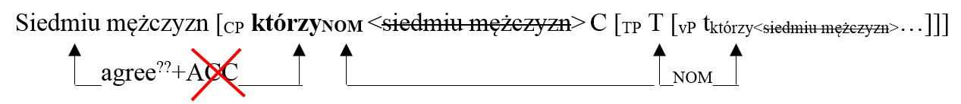

(27) siedem kobiet, **które** weszły/weszło do domu

seven-ACC women-GEN whoNOM/ACC entered-3PL,NON-VIR/3SG,NEUT. into house

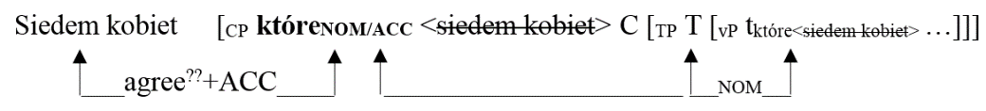

Some evidence for (case) feature sharing, or more generally, communication between the external HN and the relative operator, comes from case matching effects in resumption (28).

(28) Polish

a. Mężczyzna, [**co *(go)** widziałem], kocha Marię

manNOM that himACC I.saw loves Mary

‘The man that I saw loves Mary.’

b. Widziałem mężczyznę, [ **co (go)** Maria kocha].

I.saw manACC that himACC Mary loves

‘I saw the man that Mary loves.

In (28a), the resumptive pronoun is obligatory, since it is an accusative object whereas the HN is nominative. However, when the same accusative object is inside a RC which modifies an accusative object HN, resumption is optional. This brings up the question of how the choice between the resumption and gap strategies is made before the external HN is merged and before case matching between the two takes place, the answer to which is outside the scope of the present paper.

Case transmission in step 3 seems to be possible due to the syncretism of the accusative and nominative forms of the non-virile pronoun, which matches in case marking with the accusative form of the higher numeral in the HN, and therefore Case transmission necessarily applies only in this context. Case transmission could be implemented by the Case stacking mechanism (Vogel 2001), which will be explained in more detail in the next sections. 4) Finally, after Accusative Case is stacked onto the relative operator/pronoun, the verbal predicate inside the RC is realised in the default form. This would indicate that the Case checking established in step 1 should be suppressed until step 3; that is, probing for Case in a RC should be delayed. Then, if Case attraction takes place, default agreement is observed due to the accusative-marked subject relative operator. If it does not take place, the nominative-marked subject relative operator induces full agreement on the verb. This solution faces some problems which are discussed in §2.5.4.

2.5.3. Case attraction in object relative clauses

The same process of case transmission does not occur with the object RCs examined in this paper, not even in the case of accusative objects in which the GoQ displays the heterogeneous pattern with an accusative quantifier and a genitive noun complement, as in (29). Therefore, case matching between the head noun and the relative pronoun is not enough to enable Case transmission between the HN and the relative operator.

(29) Poznałem siedem kobiet **które**

I.met**+ACC** seven-ACC women-GEN,non-vir who-NOM/ACC weszły/??weszło do domu.

entered-3PL,NON-VIR/3SG,NEUT into house

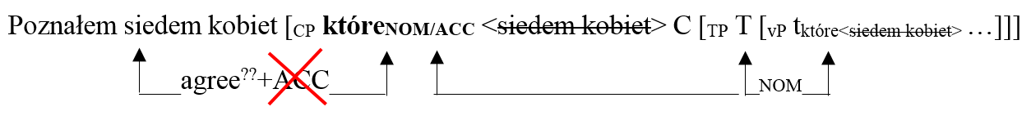

Although the lack of Case attraction between an oblique GoQ head noun and a subject relative operator/pronoun is expected, since the quantifier is no longer marked for accusative case (see (18b-c) above), the absence of this mechanism is surprising with accusative object head nouns. With oblique GoQ, oblique case transmitted onto the relative pronoun would make the pronoun incompatible with the subject-internal GoQ head, resulting in, for example, \**którymDAT siedemACC kobietGEN* ‘which <seven women>’. With accusative GoQ, on the other hand, application of the same mechanism would not yield incompatibility of forms, yet Case transmission is not observed. One possible explanation for this effect could be that, since it is the inherent Accusative Case of the quantifier that forces default agreement, structural Accusative Case assigned to the object HN inside the matrix clause prevents Case transmission of the inherent Accusative Case from the quantifier to the relative pronoun.

2.5.4. Case attraction and Case stacking

A mechanism that could be at work for subject relatives in contexts which allow Case transmission (as suggested in Łęska 2016) is Case stacking (Vogel 2001).[5] Case stacking has been reported in e.g. Lardil ((30) from Richards 2013, cited in Manzini et al. this volume). In (30), the DP *marunngan-ku* ‘boy-gen-instr’ is inflected for two cases, being the possessor of the instrumental nominal *maarnku* ‘spear-instr’. Furthermore, not only case suffixes, but also phi-feature inflection can be stacked, as the following example from Punjabi shows ((31) from Manzini et al. 2015: 316).

(30) Lardil

Ngada latha karnjin-i marun-ngan-ku maarn-ku

I spear wallaby-acc boy-gen-instr spear-instr

‘I speared the wallaby with the boy’s spear.’

(31) Punjabi

muɳɖ- e- d- i/-ĩã kita:b/ kitabb-a

boy -msg- gen- fsg/-fpl book.abs.fsg/ book-abs.fpl

‘the book/the books of the boy’

(Manzini et al. 2015: 316)

In Punjabi, masculine singular nouns followed by a postposition are sensitive to the direct/oblique case distinction as far as phi-feature inflection is concerned. Thus, the inflection on the noun *muɳɖ*- ‘boy’ is as follows: the suffix -*e* stands for masculine (oblique), next to it we find the genitive suffix *d*-, and, on top of that, the noun inflects for the phi-features of the head noun (*i/-ĩã*). However, since the subject-verb agreement patterns in Polish RCs depend strongly on the presence or absence of Accusative Case on the HN, as was argued for GoQ structures in Bošković (2006) and Witkoś & Dziubała-Szrejbrowska 2016 (see §2.2), Case stacking will be of more interest for the present analysis.

Trying to apply Case attraction and Case stacking to RC structures, Łęska (2016) states that whenever Case attraction is possible and the Case of the external head noun is stacked on the relative pronoun, the second/transmitted Case is realized on the pronoun; that is, Accusative. As the evidence from Case attraction languages shows, this mechanism is only possible when the Case on the external head is more oblique than the Case checked on the internal head/relative operator. As a result, the relative operator is marked for the more oblique case. Assuming Case feature decomposition (Assmann 2013; Georgi & Salzmann 2014), this could be executed in the following way: when the two sets of features are stacked, they fuse into the Case which constitutes a superset of features; i.e. is more oblique (for fusion of Case features under stacking, see Assmann et al. 2014).

Additionally, it seems that the morphological case form of the relative pronoun determines the accessibility of Case attraction in Polish. Whereas the non-virile pronoun has a syncretic nominative/accusative form, the nominative form of the virile pronoun is not syncretic, being incompatible with the relativized numeral phrase, as was seen in (23). A similar analysis of inverse (Case) attraction was adapted for Croatian *što*-relatives in Gračanin-Yuksek (2013), which is based on morphological case forms, as opposed to abstract Case features. Thus, it is the matching of the morphological case forms of the internal and external heads, and not the abstract Case checked by them, that enables dropping of the resumptive pronoun within *što*-relatives (see §1.3). Likewise, syncretism of case forms can rescue the derivation of Polish free relatives (Assmann 2014). As can be seen in (32a-b), Polish free relatives require strict case matching. Nevertheless, when the morphological form of the relative pronoun is syncretic, matching the Case features of both probes, the sentence is grammatical (32c) (Assmann 2014: 3).

(32) a. Jan lubiACC **kogokolwiekACC** Maria lubiACC.

John likes whoever Maria likes

b. Jan ufaDAT **\*komukolwiekDAT/*kogokolwiekACC**

John trusts whoever wpuściłACC do domu.

let to home

‘John trusts whoever he let into the house.’

c. Jan unikaGEN **kogokolwiekACC/GEN** wczoraj obraziłACC

John avoids whoever yesterday offended

‘John avoids whoever he offended yesterday.’

Therefore, the conclusion can be drawn that Case attraction in Polish *który*-relatives is possible only if the morphological form of the relative pronoun is compatible with the case marking on the external head noun, which in this case is accusative GoQ.

In Polish subject *co*-relatives, the relativization site is realized as a gap due to the lack of subject resumption. Since the null operator does not have any morphological form, the relative operator for both virile and non-virile head nouns can undergo Case attraction (Łęska 2016). Yet this mechanism applies only to subject GoQ head nouns ((33) from Łęska 2016: 131), as opposed to object head nouns (34), which patterns with the observation made for *który*-relatives. Therefore, it could be concluded that default agreement with the predicate of the RC is not possible with object GoQ head nouns in general, following from the assumption that the Accusative Case of the quantifier on the external head noun can be transmitted only from subject GoQ.

(33) siedmiu mężczyzn, **co** weszli/weszło do domu

seven-ACC men-GEN comp entered-3PL,VIR/3SG,NEUT. into house

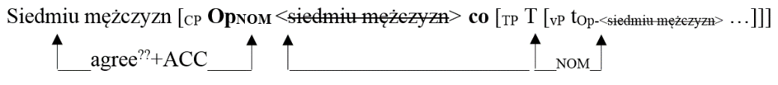

(34) Spotkałem siedmiu mężczyzn, **co** weszli/*weszło

I.met seven-ACC men-GEN comp entered-3PL,VIR/3SG,NEUT. do domu.

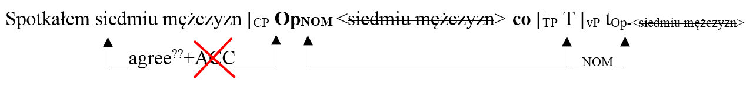 into house

All in all, if Case attraction constitutes an attractive explanation for the agreement facts discussed here, it must be structurally restricted for Polish relatives so that it does not overgenerate. Since accusative GoQ in *object position* cannot induce default agreement, as the present study has revealed, Case attraction and Case stacking must be further restricted by the structural position of the head noun, such that only a subject HN can transmit Accusative Case onto the subject relative pronoun. This can be explained by the fact that an object GoQ phrase is marked for structural Accusative and, thus, transmission of inherent Accusative Case from the higher numeral in the HN is blocked. That is, for Case attraction to be possible, both the relative operator and the external head need to be probed by the same type of probe, namely the internal and external T0. This, on the other hand, would make Case attraction undetectable in all other environments, limiting it to the situation in which a non-nominative subject of the matrix clause undergoes subject relativization. In fact, Case attraction is not otherwise observed with Polish relatives.

Importantly, if the same kind of feature sharing involving Accusative Case took place between the internal, and not external, head noun and the relative pronoun/operator, default agreement would be observed for both types of RC modifying any object QP, which, as this study has shown, is impossible. One problem mentioned in Łęska (2016) with regard to this analysis involves the point in the derivation at which subject-verb agreement is established. Since Case attraction occurs after the movement of the relative operator to SpecCP, for default agreement to be possible, the agreement relation needs to be suppressed and established after the mechanism of Case attraction applies, which requires lookahead and goes against the Earliness Principle (Pesetsky 1989). Yet another solution applying the Case attraction mechanism could be to stipulate that the Case value of the relative pronoun is overwritten at PF (Bianchi 2000: 68–69; Spyropolous 2011) or that Case values in general are assigned at PF (Alexiadou & Varlokosta 2007; Assmann 2014). As a consequence, however, default verbal agreement would also be the result of a post-syntactic operation. This and other issues could be resolved after closer examination of case matching restrictions and resumption strategies in Polish relatives, which would constitute interesting topics for future research.

3. Conclusion

The subject-verb agreement patterns found in Polish *co*- and *który*-relatives modifying subject head nouns suggest that movement of the head noun out of the RC in Polish should not be involved in the derivation of these structures, since they both allow optionality of agreement in certain contexts. The only asymmetry arises with respect to the context in which such optionality may occur. That is, whereas subject *co*-relatives allow either full or default agreement regardless of the grammatical gender of their head nouns, subject *który*-relatives show the same pattern only when the case forms of the relative pronoun and the numeral head noun are compatible, which is the case with non-virile nominals. The asymmetry between Polish virile and non-virile head nouns can be attributed to the accusative-nominative syncretism, which is uniformly found among the non-virile relative pronoun *który* and higher numerals. Because its morphological case form is always compatible with the numeral case form, the Accusative Case feature of the external numeral phrase can be erroneously extended to the relative pronoun (or null operator), resulting in default agreement on the verbal predicate within the relative. This, however, is impossible for numeral phrases containing virile nouns, due to the unambiguously nominative form of the virile relative pronoun. The same optionality in agreement is not available for object GoQ head nouns in either *co*- or *który*-relatives and regardless of the grammatical gender of the head noun. This result suggests that Case attraction can apply only when the external head noun is an accusative-marked GoQ subject.

References

Aghaei, Behrad. 2006. The syntax of *ke*-clauses and clausal extraposition in Modern Persian. Ann Arbor, MI: University of Michigan. (Doctoral dissertation.)

Alexiadou, Artemis & Varlokosta, Spyridola. 2007. The syntactic and semantic properties of free relatives in Modern Greek. In Alexiadou, Artemis (ed.), *Studies in the morpho-syntax of Greek*, 222–251. Newcastle: Cambridge Scholars Publishing.

Assmann, Anke. 2013. Three stages in the derivation of free relatives. InHeck, Fabian & Assmann, Anke (eds.), *Rule interaction in grammar*, 203–245. Leipzig: University of Leipzig.

Assmann, Anke. 2014. On variation in and across languages: Case matching effects with free relatives and parasitic gaps in German and Polish. (Paper presented at the workshop What happened to Principles & Parameters?, Villa Salmi, Arezzo, 3 July 2014.)

Assmann, Anke & Edygarova, Svetlana & Georgi, Doreen & Klein, Timo & Weisser, Philipp. 2014. Case stacking below the surface: On the possessor case alternation in Udmurt. *The Linguistic Review* 31. 447–485.

Bacskai-Atkari, Julia. 2016. On the diachronic development of a Hungarian declarative complementiser. *Transactions of the Philological Society* 114. 95–116.

Bader, Marcus & Bayer, Josef. 2006. *Case and linking in language comprehension: Evidence from German*. Dordrecht: Springer.

Bhatt, Rajesh. 2002. The raising analysis of relative clauses: Evidence from adjectival modification. *Natural Language Semantics* 10. 43–90.

Bianchi, Valentina. 1999. *Consequences of antisymmetry: Headed relative clauses.* Berlin & New York: Walter de Gruyter.

Bianchi, Valentina. 2000. Some issues in the syntax of relative determiners. In Alexiadou, Artemis & Law, Paul & Meinunger, André & Wilder, Chris (eds.), *The syntax of relative clauses*, 53–81. Amsterdam & Philadelphia: John Benjamins.

Bondaruk, Anna. 1995. Resumptive pronouns in English and Polish. In Gussmann, Edmund (ed.), *Licensing in syntax and phonology*, 27–55. Lublin: Folium.

Bošković, Željko. 2006. Case and agreement with genitive of quantification in Russian. In Boeckx, Cedric (ed.). *Agreement systems*, 99–120. Amsterdam: John Benjamins.

Buttler, Danuta & Kurkowska, Halina & Satkiewicz, Halina. 1971. *Kultura języka polskiego: Zagadnienia poprawności gramatycznej.* Warszawa: Wydawnictwo Naukowe PWN.

Chierchia, Gennaro & McConnell-Ginet, Sally. 1990. *Meaning and grammar*. Cambridge, MA: MIT Press.

Citko, Barbara. 2004. On headed, headless, and light-headed relatives. *Natural Language & Linguistic Theory* 22. 95–126.

Dziubała-Szrejbrowska, Dominika. 2014. *Aspects of morphosyntactic constraints on quantification in English and Polish*. Poznań: Adam Mickiewicz University in Poznań. (Doctoral dissertation.)

Fisiak, Jacek & Lipińska-Grzegorek, Maria & Zabrocki, Tadeusz. 1978. *An introductory English-Polish contrastive grammar*. Warsaw: Wydawnictwo Naukowe PWN.

Franks, Steven. 1994. Parametric properties of numeral phrases in Slavic. *Natural Language & Linguistic Theory* 12. 570–649.

Gračanin-Yuksek, Martina. 2013. The syntax of relative clauses in Croatian. *The Linguistic Review* 30. 25–49.

Grosu, Alexander. 1994. *Three studies in locality and case*. London: Routledge.

Harbert, Wayne. 1983. A note on Old English free relatives. *Linguistic Inquiry* 14. 549–553.

Hulsey, Sarah & Sauerland, Uli. 2006. Sorting out relative clauses. *Natural Language Semantics* 14. 111–137.

Kayne, Richard. 1994. *The antisymmetry of syntax*. Cambridge, MA: MIT Press.

Lavine, James. 2003. Resumption in Slavic: Phases, cyclicity, and case. In Browne, Wayles & Kim, Ji-Yung & Partee, Barbara H. & Rothstein, Robert A. (eds.), *Formal Approaches to Slavic Linguistics 11*, 355–372. Ann Arbor, MI: Michigan Slavic Publications.

Łęska, Paulina. 2016. Agreement under Case Matching in Polish *co* and *który* relative clauses headed by numerically quantified nouns. *Journal of Slavic Linguistics* 24. 113–136.

Łoś, Jan. 1910. *Składnia zdania*. Kraków: Koło Slawistów.

Manzini, M. Rita & Savoia, Leonardo M. & Franco, Ludovico. 2015. Ergative case, aspect and person splits: Two case studies. *Acta Linguistica Hungarica* 62. 297–351.

Manzini, M. Rita & Franco, Ludovico & Savoia, Leonardo M. 2018. Suffixaufnahme, oblique case and Agree. This volume.

McCloskey, James. 2011. Resumptive pronouns, A′-binding, and levels of representation in Irish. In Rouveret, Alain (ed.), *Resumptive pronouns at the interfaces*, 65–120*.* Amsterdam & Philadelphia: John Benjamins.

Merchant, Jason. 2004. Resumptivity and non-movement. *Studies in Greek Linguistics* 24. 471–481.

Minlos, Philip R. 2012. Slavic relative *čto*/*co*: Between pronouns and conjunctions. *International Journal of Slavic Studies* 1. 74–91.

Mitrović, Ivana. 2008. Resumptive pronouns in Serbian subject and object relatives. (Paper presented at the 10th CUNY/SUNY/NYU Mini-Conference, CUNY Graduate Center, 22 November 2008.)

Mykowiecka, Agnieszka. 2001. Polish relatives with the marker *co*. In Przepiórkowski, Adam & Bański, Piotr (eds.), *Generative linguistics in Poland: Syntax and morphosyntax,* 149–158. Warszawa: Instytut Podstaw Informatyki Polskiej Akademii Nauk.

Pesetsky, David. 1989. Language-particular processes and the Earliness Principle. Ms. (Cambridge, MA: MIT.)

Pittner, Karin. 1995. The case of German relatives. *The Linguistic Review* 12. 197–231.

Przepiórkowski, Adam. 2004. O wartości przypadka podmiotów liczebnikowych. *Biuletyn Polskiego Towarzystwa Językoznawczego* LX. 133–143.

Richards, Norvin. 2013. Lardil “case stacking” and the timing of Case assignment. *Syntax* 16. 42–76.

Rutkowski, Paweł. 2002. The syntax of quantifier phrases and the inherent vs. structural case distinction. *Linguistic Research* 7. 43–74.

Safir, Ken. 1999. Vehicle change and reconstruction in A-bar chains. *Linguistic Inquiry* 30. 587–620.

Salzmann, Martin & Georgi, Doreen. 2014. Case attraction and matching in resumption in relatives: Evidence for top-down derivation. In Assmann, Anke & Bank, Sebastian & Georgi, Doreen & Klein, Timo & Weisser, Philipp & Zimmermann, Eva (eds.), *Topics at Infl,* 347–395. Leipzig: University of Leipzig.

Sauerland, Uli. 2002. Unpronounced heads in relative clauses. In Schwabe, Kerstin & Winkler, Susanne (eds.), *The interfaces: Deriving and interpreting omitted structures,* 205–226. Amsterdam: John Benjamins.

Skwarski, Filip. 2010. Agreement issues in Polish co-relative clauses. (Paper presented at the 17th International Conference on HPSG, Warsaw, 9–10 July 2010.)

Spyropoulos, Vassilios. 2011. Case conflict in Greek free relatives: Case in syntax and morphology. In Galani, Alexandra & Hicks, Glyn & Tsoulas, George (eds.), *Morphology and its interfaces,* 21–56. Amsterdam: John Benjamins.

Szczegielniak, Adam. 2005. Relativization that you did. (*MIT Occasional Papers in Linguistics* 24). Cambridge: MIT Working Papers in Linguistics.

Szczegielniak, Adam. 2006. Two types of resumptive pronouns in Polish relative clauses. In Pica, Pierre & Rooryck, Johan & van Craenenbroeck, Jeroen (eds.), *Linguistic Variation Yearbook* *2005,* 165–185. Amsterdam & Philadelphia: John Benjamins.

Vogel, Ralf. 2001. Towards an optimal typology of the Free Relative construction. In Grosu, Alex (ed.), *Papers from the Sixteenth Annual Conference and from the research workshop of the Israel Science Foundation* “*The Syntax and Semantics of Relative Clause Constructions*”, 107–119*.* Tel Aviv: Israel Association for Theoretical Linguistics, University of Tel Aviv.

Willim, Ewa. 2003. O przypadku fraz z liczebnikiem typu pięć w podmiocie i mechanizmach akomodacji. *Polonica* 22/23. 233–254.

Witkoś, Jacek & Dziubała-Szrejbrowska, Dominika. 2016. Numeral phrases as subjects and agreement with participles and predicative adjectives. *Journal of Slavic Linguistics* 24. 225–260.

1. The advocates of the raising analysis, however, assume that the Case features of the relative D0 heads are checked and erased by the time the noun head gets to the SpecCP position, thus allowing the same noun head to be assigned Case by the matrix D0 head (Kayne 1994; Bianchi 2000; Citko 2004).
2. The reason why *który*-relatives with virile head nouns were not examined is that they do not allow optionality between full and default agreement at all, as opposed to the non-virile relative pronoun in the subject position. This could be attributed to the lack of case syncretism of nominative and accusative case forms of the virile relative operator, which is explained in §2.4.
3. It is important to note that the use of invariable *co* as a relative marker is not the primary relativization strategy in Polish and may be considered totally unacceptable by some speakers, as can be seen in the diagram in Figure 2 presenting the results of the questionnaire. Furthermore, this strategy is limited to spoken language, which may have influenced the judgements of written sentences used in the questionnaire.
4. The Genitive of Quantification used in the study involved numeral phrases only.
5. One of the problems with the Case stacking analysis is, however, that it is not clear how the relative pronoun can still be active to undergo any Case-agreement relation with the external head after being Case checked with the probe within the RC (Georgi & Salzmann 2014: 352).